**PSUC Lab Assignment**

**Lab 1:**

**Q1)** Write a C program to add two integers a and b read through the keyboard. Display the result using third variable sum.

**Code**:

#include<stdio.h>

int main()

{

int a,b ;

int sum;

printf("Enter the numbers\n");

scanf("%d%d",&a,&b);

sum = a+b;

printf("the sum is %d\n",sum);

printf("My name is Saksham");

return 0;

}

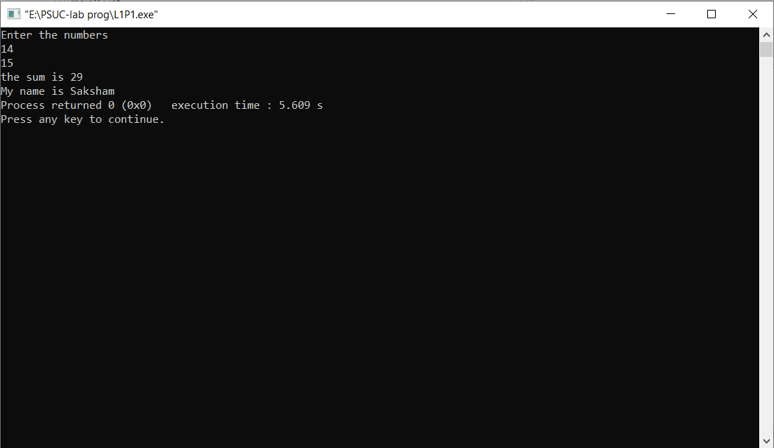**Output:**

**Q2)** Write a C program to find the sum, difference, product and quotient of 2 numbers.

**Code**:

#include<stdio.h>

int main()

{

float a,b;

float S,D,P,Q ;

printf("Enter the two numbers\n");

scanf("%f%f",&a,&b);

S = a+b;

D = a-b;

P = a*b;

Q = a/b;

printf("the Sum is %f\n",S);

printf("the Difference is %f\n",D);

printf("the Product is %f\n",P);

printf("the Quotient is %f\n",Q);

printf("My name is Saksham");

return 0;

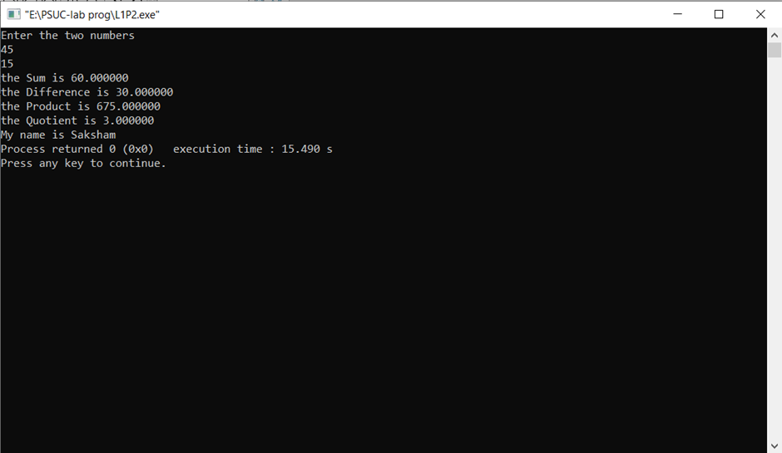}

**Output:**

**Q3)** Write a C program to print the ASCII value of a character.

**Code:**

#include<stdio.h>

int main()

{

char c ;

printf("enter the character: ");

scanf("%c",&c);

printf("ASCII value of %c=%d\n",c,c);

printf("My name is Saksham");

return 0;

}

**Output:**

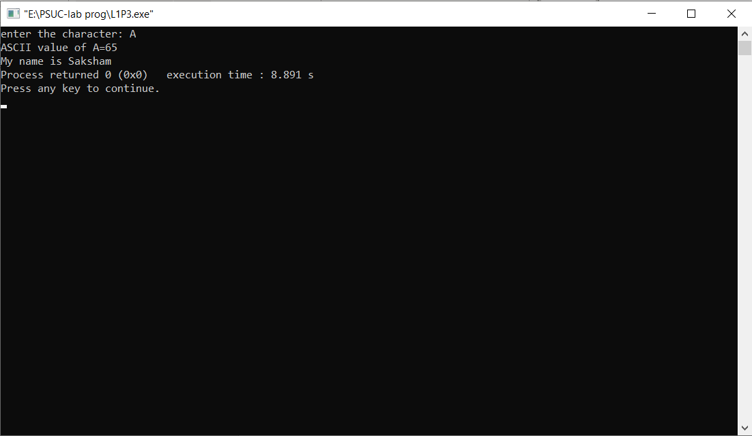

**Q4**) Write a C program to display the size of the data type int, char, float, double, long int and long double using size of ( ) operator.

Code:

#include<stdio.h>

int main()

{

printf("the size of int is %d\n",sizeof(int));

printf("the size of char is %d\n",sizeof(char));

printf("the size of float is %d\n",sizeof(float));

printf("the size of double is %d\n",sizeof(double));

printf("the size of long double is %d\n",sizeof(long double));

printf("the size of long int is %d\n",sizeof(long int));

printf("My name is Saksham");

return 0;

}

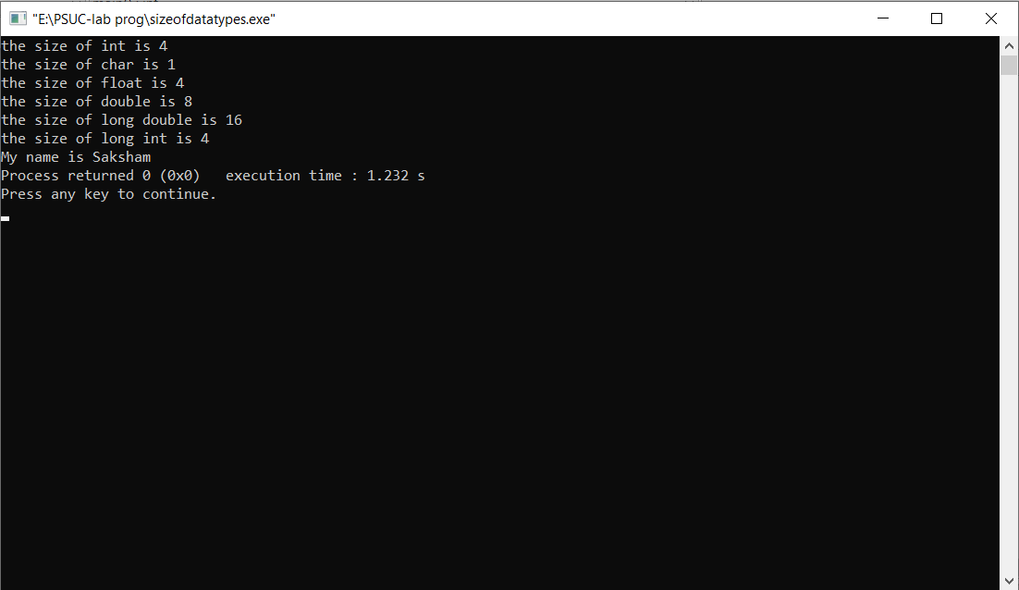**Output**:

**Q5)** Input P, N and R to compute simple and compound interest. [Hint: SI = PNR/100, CI = P(1+R/100)N-P].

**Code:**

#include<stdio.h>

#include<math.h>

int main()

{

float P,N,R ;

float SI,CI;

printf("enter principal amount , period , rate of interest \n");

scanf("%f%f%f",&P,&N,&R);

SI = (P*N*R)/100;

CI = P*pow((1+R/100),N)-P ;

printf("the simple interest is %f\n",SI);

printf("the compount interest is %f\n",CI);

printf("My name is Saksham");

return 0;

}

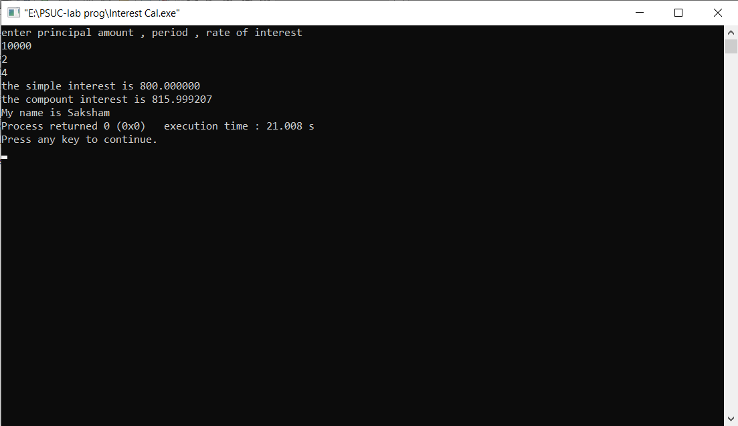**Output:**

**Q6)** Input radius to find the volume and surface area of a sphere. [Hint: volume = (4πr3)/3, Area=4πr2]

**Code:**

#include<stdio.h>

#include<math.h>

int main()

{

float R;

float V,A;

printf("Enter Radius\n");

scanf("%f",&R);

V = (4.0/3)*3.14*pow(R,3);

A = 4.0*3.14*pow(R,2);

printf("the volume of the sphere is %f\n",V);

printf("the surface area of the sphere is %f\n",A);

printf("My name is Saksham");

return 0;

}

**Output**:

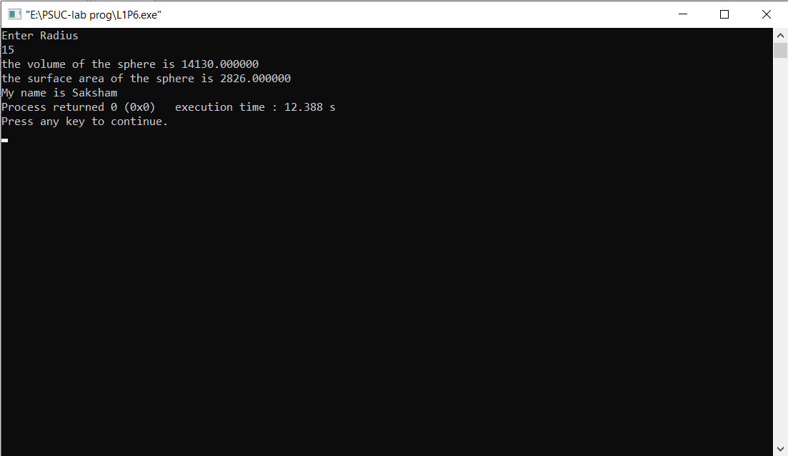

**Q7)** Convert the given temperature in Fahrenheit to Centigrade. [Hint: C=5/9(F-32)]

**Code:**

#include<stdio.h>

int main()

{

float Fh,Ct;

printf("Enter temperature in Fahrenheit\n");

scanf("%f",&Fh);

Ct = 5.0/9*(Fh-32);

printf("the temp in centigrade is %f\n",Ct);

printf("My name is Saksham");

return 0;

}

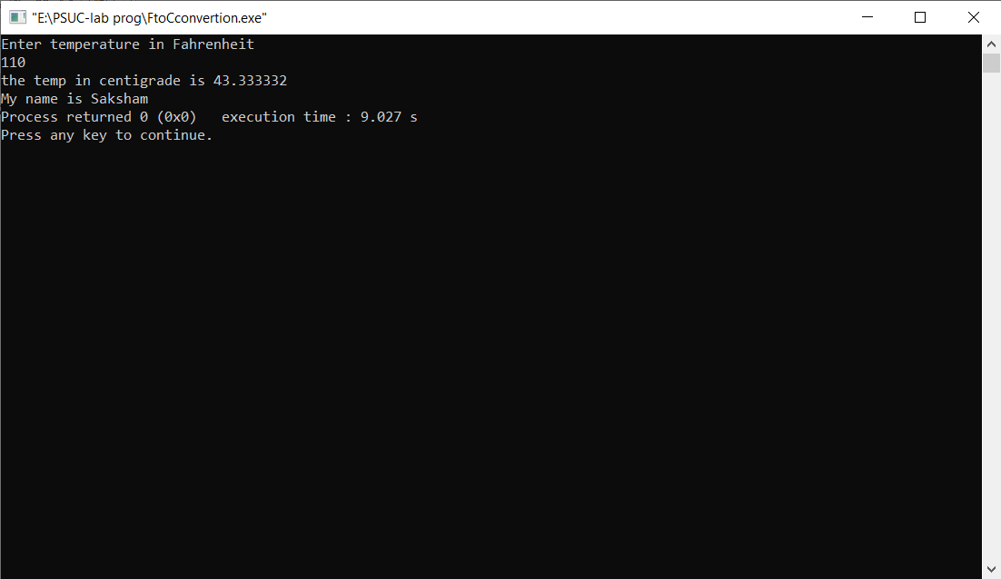**Output**:

**Q8)** Write a C program to evaluate the following expression for the values a = 30, b=10, c=5, d=15(i ) (a + b) * c / d (ii) ((a + b) * c) / d (iii) a + (b * c) / d (iv) (a + b) * (c / d)

**Code:**

#include<stdio.h>

int main()

{

int a=30,b=10,c=5,d=15;

int P,Q,R,S;

P= (a + b) * c / d ;

Q= ((a + b) * c) / d ;

R= a + (b * c) / d ;

S= (a + b) * (c / d) ;

printf("%d\n",P);

printf("%d\n",Q);

printf("%d\n",R);

printf("%d\n",S);

printf("My name is Saksham");

return 0;

}

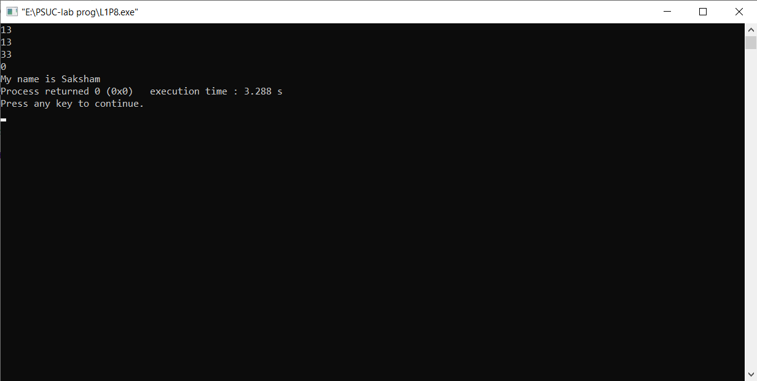**Output:**